Set 26: Online Learning / Student Mini Data Analysis
Dataset: Student_Mini_Data.csv (Student_ID, Gender, Study_Hours, Attendance, Math_Score, Science_Score, Exam_Date)
1) Import the dataset in R. Plot a histogram for Math_Score. Draw a boxplot of Science_Score by Gender. Add proper title and labels. Interpret the results.
R code:
# Import dataset
student <- read.csv("Student_Mini_Data.csv")

# Histogram of Math_Score
hist(student$Math_Score,
main = "Distribution of Math Scores",
xlab = "Math Score", ylab = "Frequency",
col = "lightblue", border = "black", breaks = 5)

# Boxplot of Science_Score by Gender
boxplot(Science_Score ~ Gender, data = student,
main = "Science Score by Gender",
xlab = "Gender", ylab = "Science Score",
col = c("#87CEFA", "#FFB6C1"))
output:
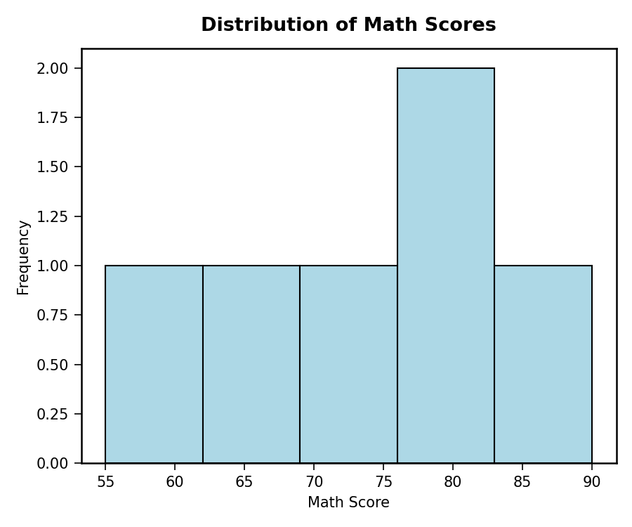
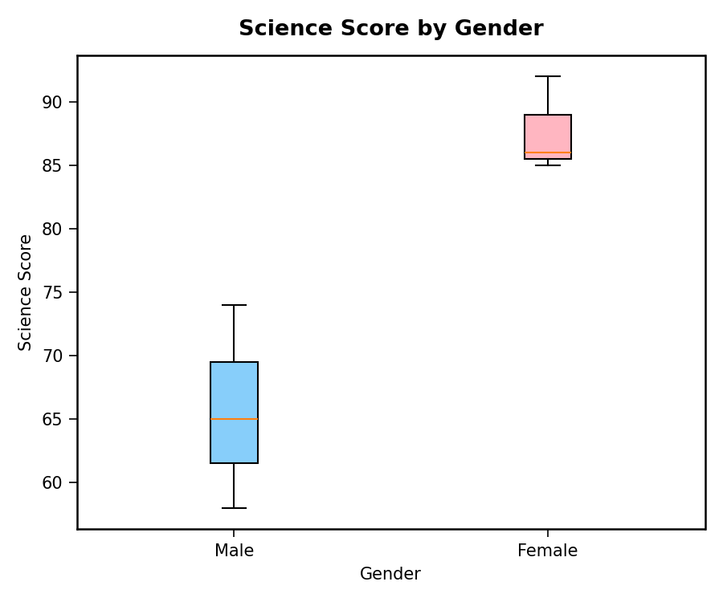
2) Create a scatter plot using R programming between Study_Time and Math_Score. Use different colors for Gender. Add a regression line. Explain the relationship between study time and performance.
R code:
# Scatter plot with regression line
plot(student$Study_Hours, student$Math_Score,
col = ifelse(student$Gender == "Male", "blue", "red"),
pch = 16, cex = 1.5,
xlab = "Study Hours", ylab = "Math Score",
main = "Study Hours vs Math Score")
legend("topleft", legend = c("Male","Female"), col = c("blue","red"), pch = 16)

# Regression Line
abline(lm(Math_Score ~ Study_Hours, data = student), col = "black", lwd = 2, lty = 2)
output:
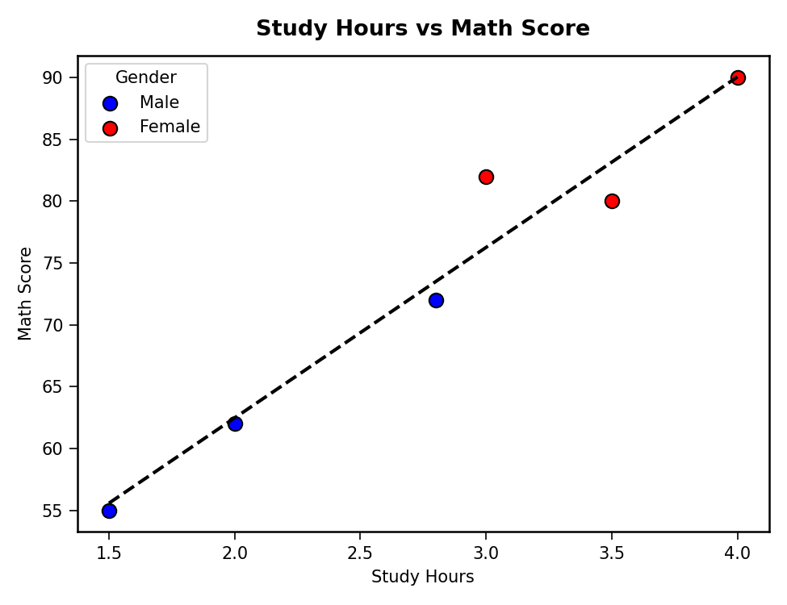
3) Using R programming, convert Login_Date into Date format. Calculate average quiz score per month. Plot a line chart. Apply moving average smoothing. Identify the trend.
R code:
# Convert Exam_Date to Date format
student$Exam_Date <- as.Date(student$Exam_Date)
student$Month <- format(student$Exam_Date, "%Y-%m")

# Average Math score per month
monthly_avg <- aggregate(Math_Score ~ Month, data = student, FUN = mean)

# Line Chart
plot(monthly_avg$Math_Score, type = "o", col = "blue", lwd = 2,
xaxt = "n", xlab = "Month", ylab = "Average Math Score",
main = "Monthly Average Math Score Trend")
axis(1, at = 1:nrow(monthly_avg), labels = monthly_avg$Month)

# Moving Average Smoothing
library(zoo)
ma <- rollmean(monthly_avg$Math_Score, k = 2, fill = NA, align = "right")
lines(ma, col = "orange", lwd = 2, lty = 2, type = "o")
legend("topleft", legend = c("Monthly Avg","Moving Avg (2)"), col = c("blue","orange"), lty = c(1,2))
output:
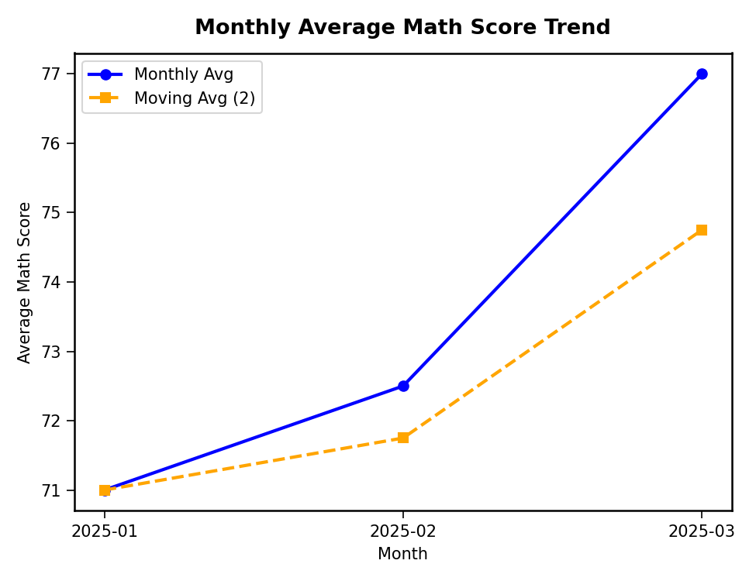
4) Import Student_Mini_Data.csv into Tableau. Create a bar chart showing average Math scores by Gender. Create a line chart for score trends over time. Add a filter for Exam_Date. Design a simple interactive dashboard.
R code (dashboard simulation):
par(mfrow = c(1, 2))
gender_avg <- aggregate(Math_Score ~ Gender, data = student, FUN = mean)
barplot(gender_avg$Math_Score, names.arg = gender_avg$Gender,
col = c("#FF9999","#99CCFF"), xlab = "Gender", ylab = "Avg Math Score",
main = "Average Math Score by Gender")
plot(monthly_avg$Math_Score, type = "o", col = "blue", lwd = 2,
xaxt = "n", xlab = "Month", ylab = "Avg Math Score",
main = "Score Trend Over Time")
axis(1, at = 1:nrow(monthly_avg), labels = monthly_avg$Month)
output:
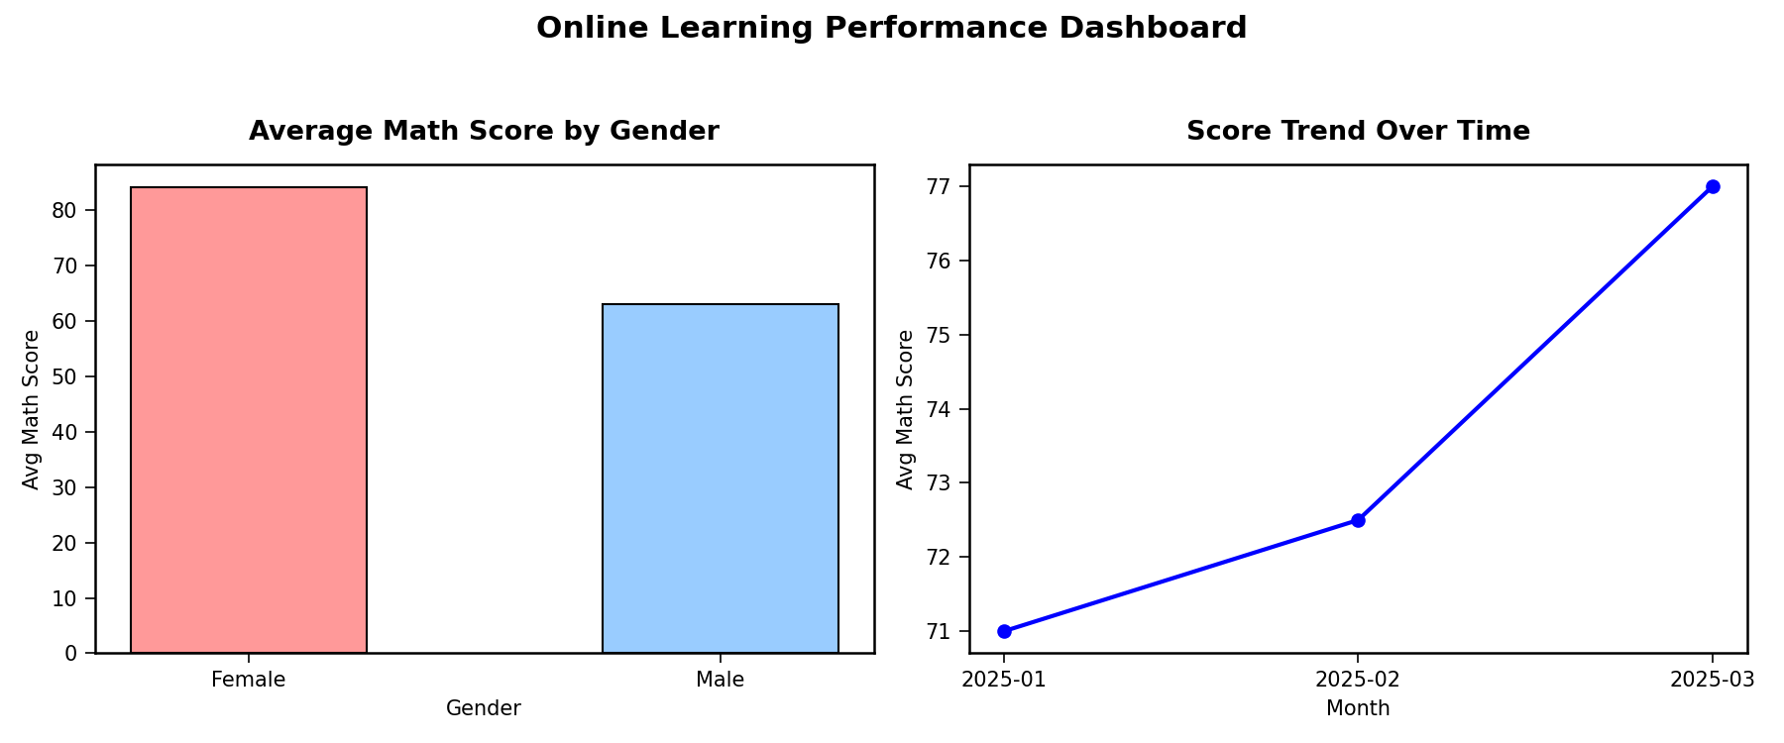
Dataset table used:
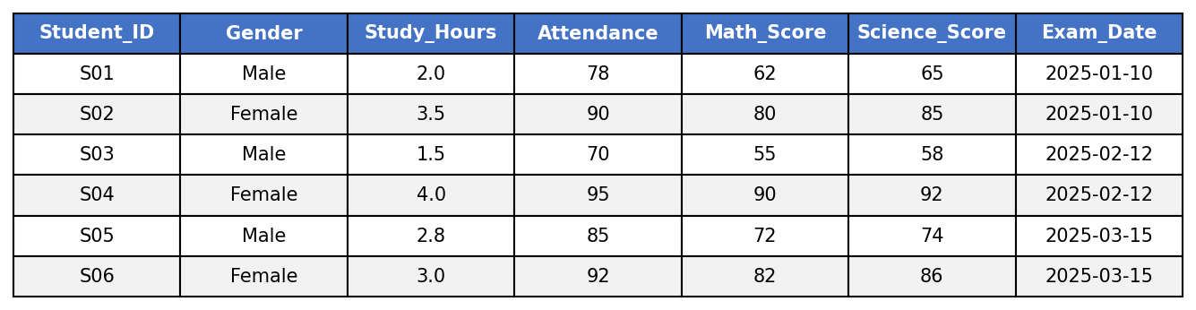

Set 27: Patient Health Risk Analysis
Dataset: Patient_ID, Age, BMI, BP, Cholesterol
1) Using R, create a scatterplot matrix for Age, BMI, BP, and Cholesterol. Examine pairwise relationships to identify strong correlations, clusters, or potential risk patterns.
R code:
# Dataset
patient <- data.frame(
Patient_ID = c("P1","P2","P3","P4","P5"),
Age = c(25, 40, 55, 35, 60),
BMI = c(22, 28, 30, 26, 32),
BP = c(120, 135, 145, 130, 150),
Cholesterol = c(180, 210, 240, 200, 260)
)

# Scatterplot Matrix
pairs(patient[, c("Age","BMI","BP","Cholesterol")],
main = "Scatterplot Matrix: Age, BMI, BP, Cholesterol",
col = "darkred", pch = 19)
output:
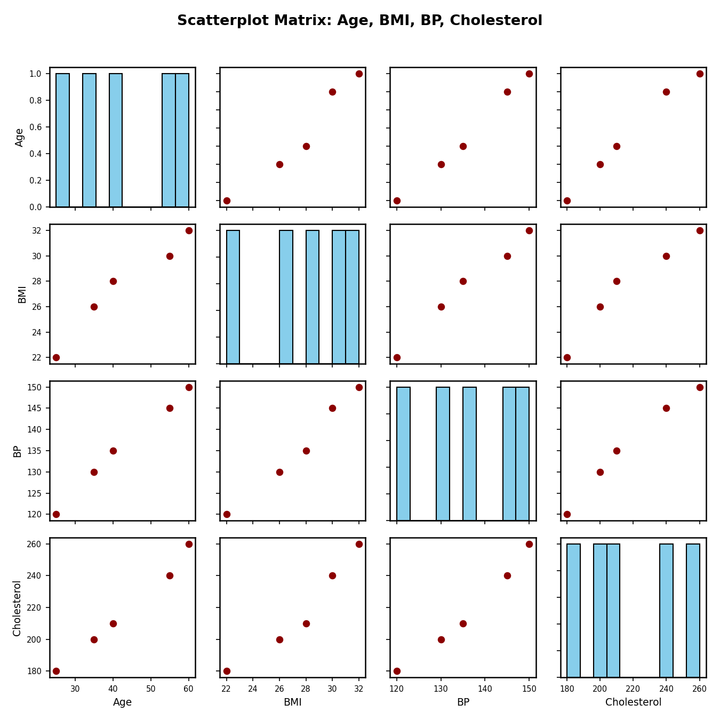
2) Construct a Q-Q plot and ECDF for Cholesterol levels to assess distribution behaviour. Comment on normality assumption and skewness.
R code:
# Q-Q Plot
qqnorm(patient$Cholesterol, main = "Q-Q Plot: Cholesterol", col = "blue", pch = 19)
qqline(patient$Cholesterol, col = "red", lwd = 2)

# ECDF
plot(ecdf(patient$Cholesterol),
main = "ECDF: Cholesterol",
xlab = "Cholesterol", ylab = "ECDF",
col = "darkgreen", lwd = 2, pch = 19)
output:
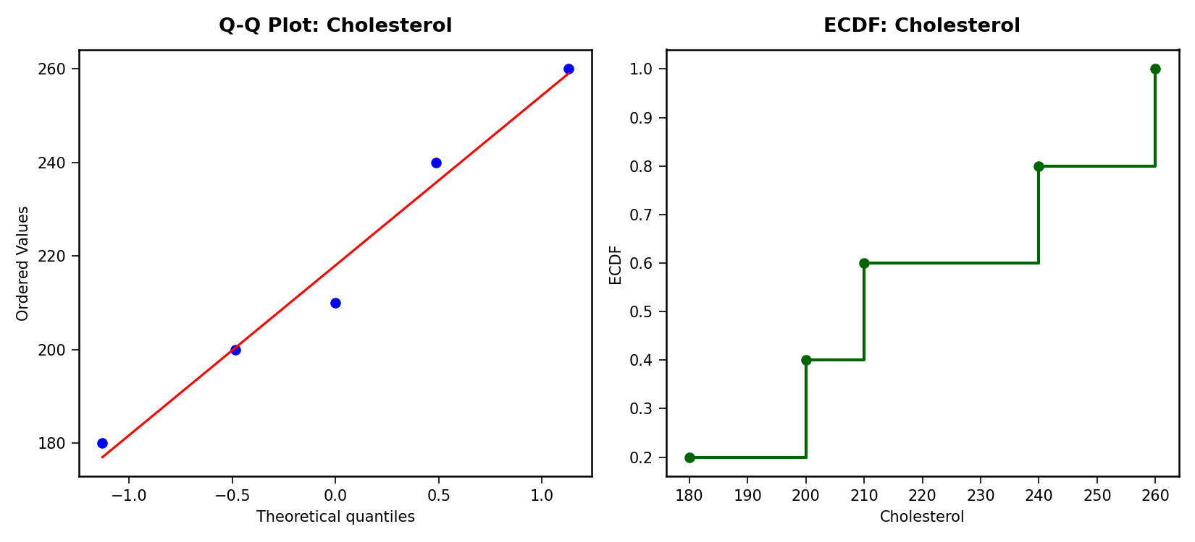
3) Using R, create a bar chart showing the average values of each health indicator (Age, BMI, BP, Cholesterol). Include axis labels, a descriptive title, and distinct colors for each bar. How do these averages relate to general patient health risk?
R code:
# Average of each indicator
avg_vals <- colMeans(patient[, c("Age","BMI","BP","Cholesterol")])

# Bar Chart
barplot(avg_vals,
col = c("#66C2A5","#FC8D62","#8DA0CB","#E78AC3"),
xlab = "Health Indicator", ylab = "Average Value",
main = "Average Health Indicators")
output:
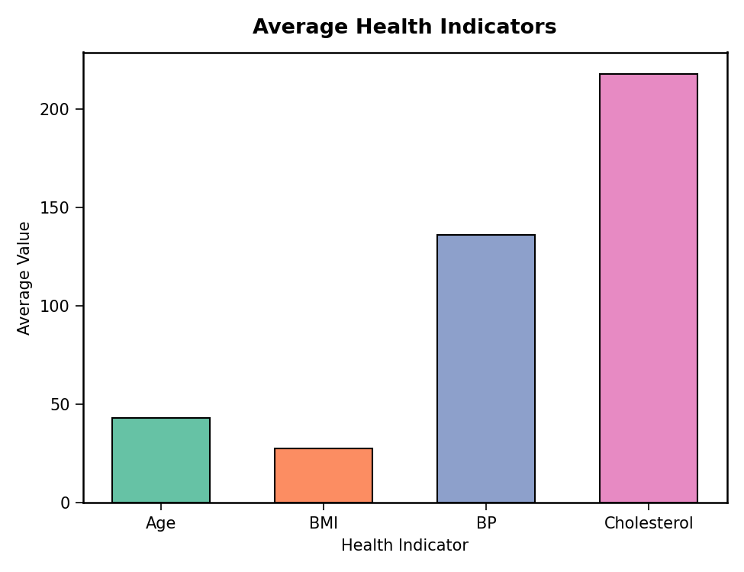
4) Create an interactive Tableau dashboard with a heatmap highlighting high-risk patients and an Age filter for exploring risk patterns. Include hover tooltips showing all health indicators. Analyze which patients are highest risk, how age affects risk, and how this dashboard can aid healthcare professionals in prioritizing care.
R code (heatmap simulation):
# Normalize values for heatmap coloring
hm <- patient[, c("Age","BMI","BP","Cholesterol")]
hm_norm <- as.data.frame(lapply(hm, function(x) (x - min(x)) / (max(x) - min(x))))
rownames(hm_norm) <- patient$Patient_ID

# Heatmap
heatmap(as.matrix(hm_norm), Rowv = NA, Colv = NA,
col = heat.colors(20), scale = "none",
main = "Patient Risk Heatmap (Normalized)")
output:
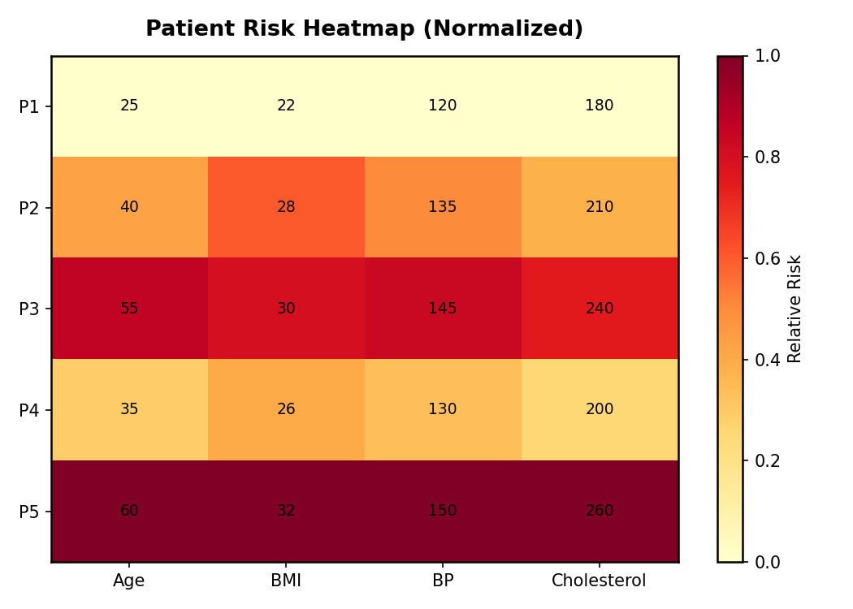
Dataset table used:
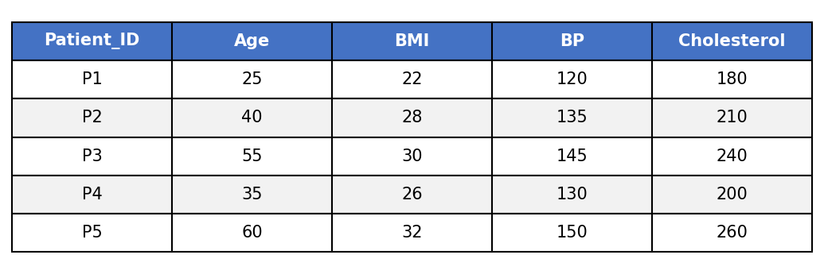

Set 28: Vehicle Performance Analysis
Dataset: Vehicle_ID, Engine_Size, Horsepower, Fuel_Efficiency, Top_Speed, Safety_Rating
1) Using R, develop a violin plot to compare the distribution of Fuel_Efficiency across different Safety_Rating categories. Examine the spread, central tendency, and variability within each group, and interpret what this indicates about efficiency patterns.
R code:
# Dataset
vehicle <- data.frame(
Vehicle_ID = c("V1","V2","V3","V4","V5"),
Engine_Size = c(1.5, 2.0, 3.0, 2.5, 1.8),
Horsepower = c(110, 150, 250, 200, 130),
Fuel_Efficiency = c(18, 15, 12, 14, 17),
Top_Speed = c(180, 200, 250, 220, 190),
Safety_Rating = c(4, 5, 5, 4, 3)
)

# Violin Plot
library(vioplot)
vioplot(Fuel_Efficiency ~ Safety_Rating, data = vehicle,
col = "lightblue",
xlab = "Safety Rating", ylab = "Fuel Efficiency (km/l)",
main = "Fuel Efficiency by Safety Rating")
output:
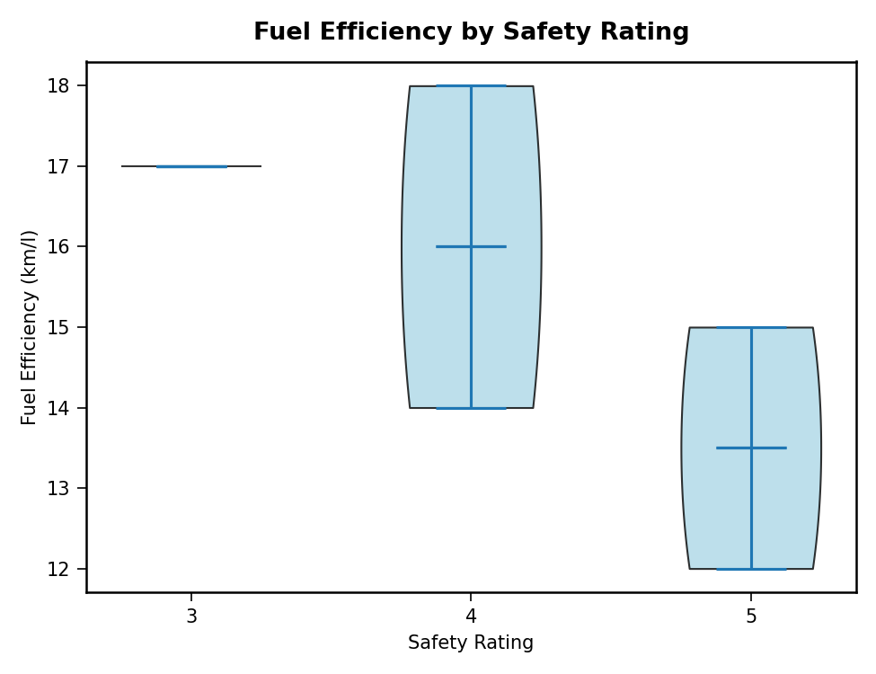
2) Using R, construct a scatter plot to explore the relationship between Horsepower and Top_Speed, applying color differentiation based on Engine_Size. Analyze the strength and direction of correlation and find observable performance trends.
R code:
# Scatter Plot colored by Engine_Size
library(ggplot2)
ggplot(vehicle, aes(x = Horsepower, y = Top_Speed, color = Engine_Size)) +
geom_point(size = 5) +
scale_color_viridis_c() +
labs(title = "Horsepower vs Top Speed",
x = "Horsepower", y = "Top Speed (km/h)", color = "Engine Size (L)")
output:
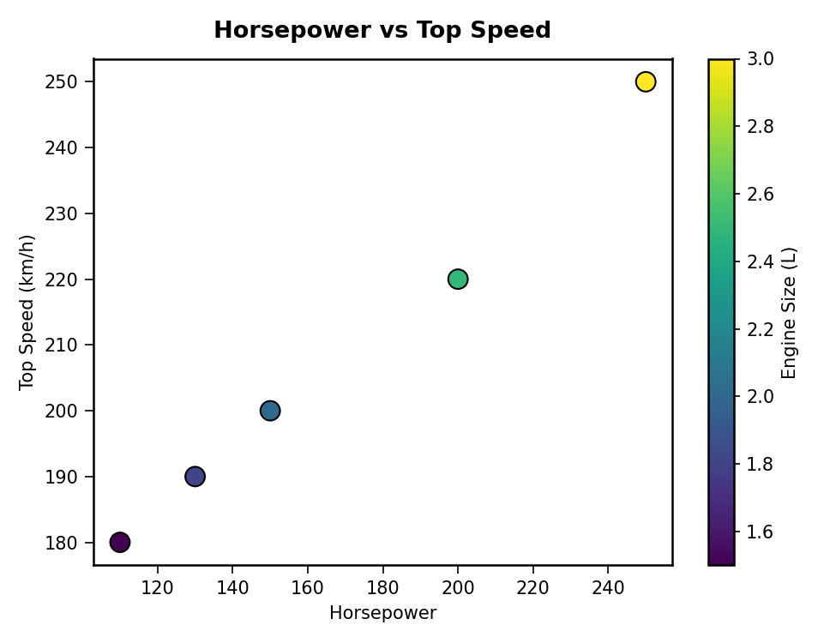
3) Using R, create a correlation heatmap for all numerical variables in the dataset. Identify the variables most strongly associated with Top_Speed and their influence on overall vehicle performance.
R code:
# Correlation matrix
num_vars <- vehicle[, c("Engine_Size","Horsepower","Fuel_Efficiency","Top_Speed","Safety_Rating")]
cor_matrix <- cor(num_vars)

# Heatmap
library(reshape2)
library(ggplot2)
melted_cor <- melt(cor_matrix)
ggplot(melted_cor, aes(x = Var1, y = Var2, fill = value)) +
geom_tile() +
geom_text(aes(label = round(value, 2))) +
scale_fill_gradient2(low = "blue", high = "red", mid = "white", midpoint = 0) +
labs(title = "Correlation Heatmap", x = "", y = "")
output:
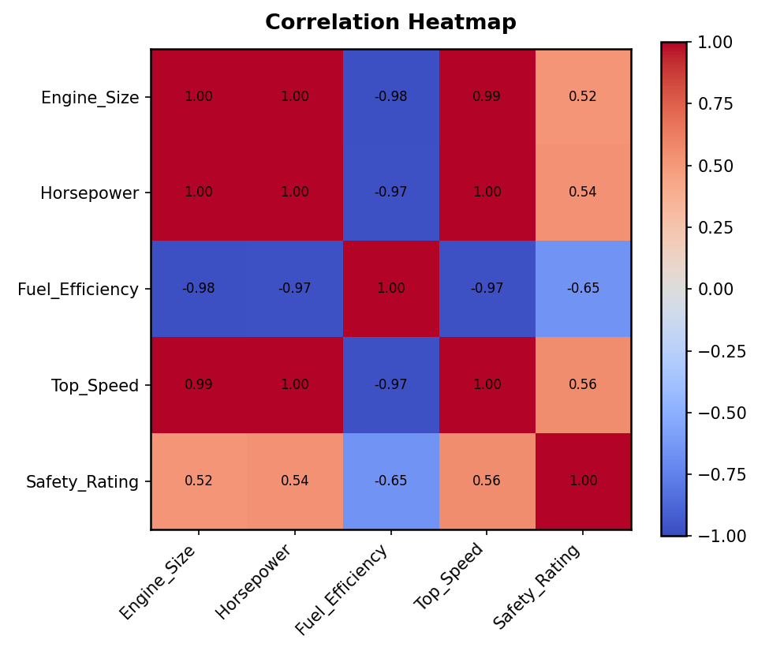
4) In Tableau, design an interactive dashboard incorporating bar charts and scatter plots, along with filters for Engine_Size and Safety_Rating, to highlight vehicles that balance fuel efficiency and high performance. Provide analytical interpretation of the insights derived from the dashboard.
R code (dashboard simulation):
par(mfrow = c(1, 2))
barplot(vehicle$Fuel_Efficiency, names.arg = vehicle$Vehicle_ID,
col = "skyblue", xlab = "Vehicle", ylab = "Fuel Efficiency (km/l)",
main = "Fuel Efficiency by Vehicle")
plot(vehicle$Horsepower, vehicle$Top_Speed,
col = vehicle$Engine_Size, pch = 19, cex = 2,
xlab = "Horsepower", ylab = "Top Speed",
main = "Horsepower vs Top Speed")
output:
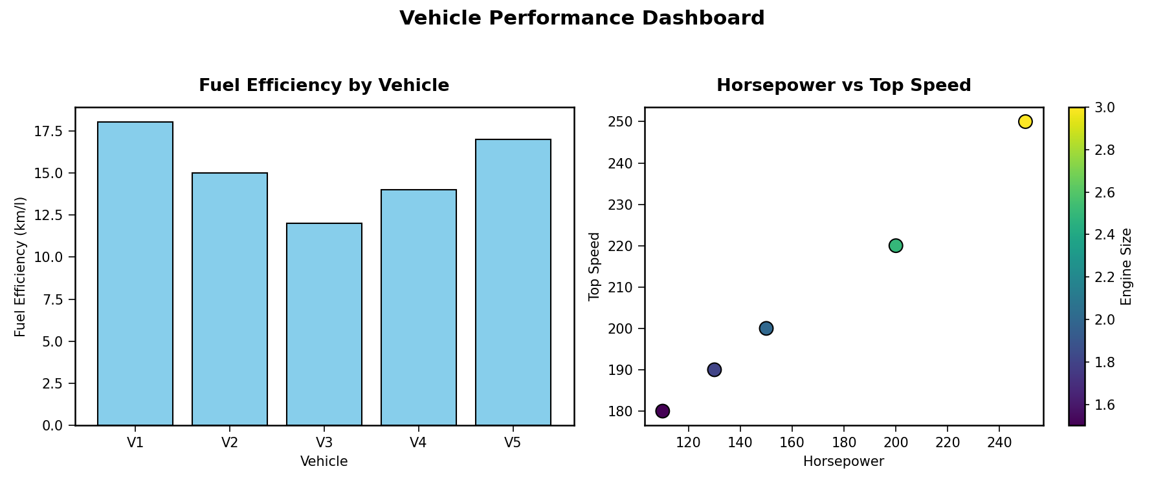
Dataset table used:
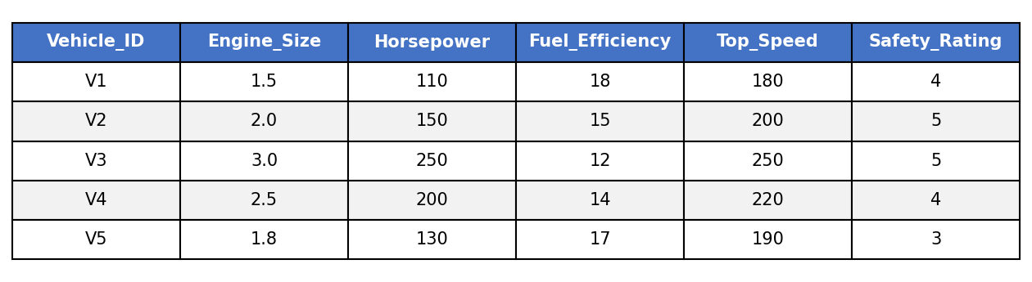

Set 29: Student Academic Performance
Dataset: Student_ID, Age, Study_Hours, Attendance, Test_Score, Participation_Score
1) Using R, create a stacked area chart showing Test_Score and Participation_Score across students. Analyze trends.
R code:
# Dataset
student <- data.frame(
Student_ID = c("S1","S2","S3","S4","S5"),
Age = c(19, 21, 20, 22, 23),
Study_Hours = c(12, 8, 15, 10, 7),
Attendance = c(90, 70, 95, 85, 60),
Test_Score = c(85, 70, 92, 80, 65),
Participation_Score = c(8, 7, 9, 8, 6)
)

# Stacked Area Chart
library(ggplot2)
library(reshape2)
student_long <- melt(student[, c("Student_ID","Test_Score","Participation_Score")], id.vars = "Student_ID")
ggplot(student_long, aes(x = Student_ID, y = value, fill = variable, group = variable)) +
geom_area(position = "stack") +
labs(title = "Test & Participation Scores (Stacked Area)", x = "Student", y = "Score")
output:
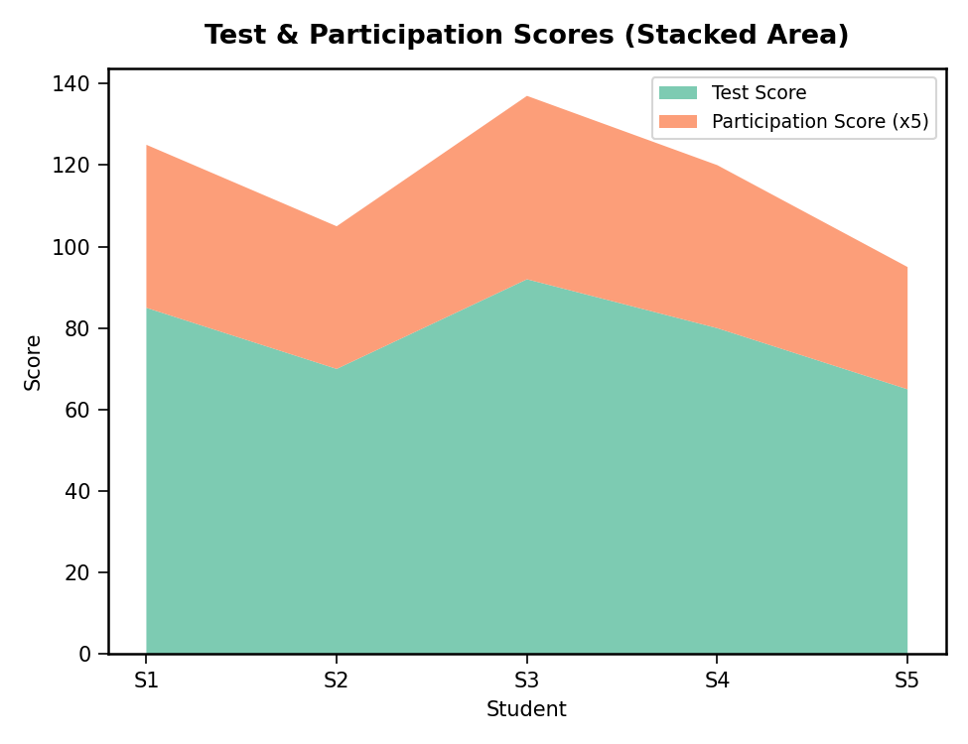
2) Using R, generate a boxplot of Study_Hours grouped by Attendance quartiles. Interpret patterns. Include axis labels, title, and colors for each quartile. Analyze the boxplot to identify median and interquartile range of study hours per attendance quartile and any outliers in study hours.
R code:
# Create Attendance Quartiles
student$Att_Quartile <- cut(student$Attendance,
breaks = quantile(student$Attendance, probs = c(0, 0.5, 1)),
include.lowest = TRUE,
labels = c("Q1(Low)", "Q2(High)"))

# Boxplot
boxplot(Study_Hours ~ Att_Quartile, data = student,
col = c("#FDB863", "#B2ABD2"),
xlab = "Attendance Quartile", ylab = "Study Hours",
main = "Study Hours by Attendance Quartile")
output:
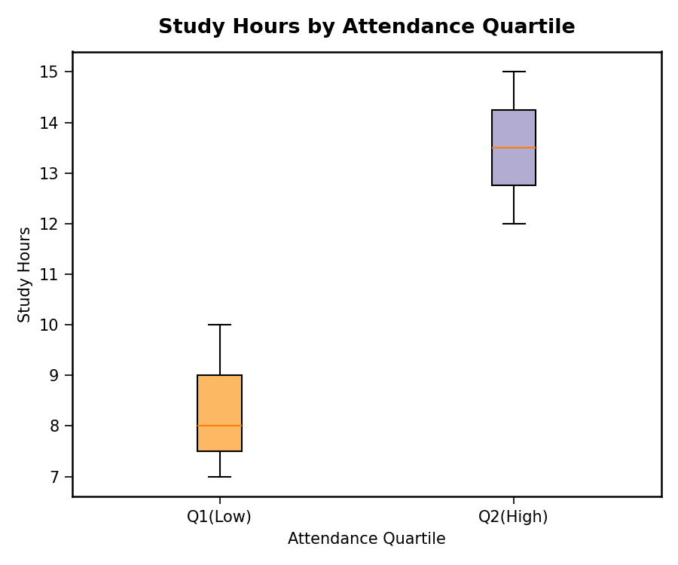
3) Using R, construct a density plot for Test_Score to evaluate score distribution and outliers.
R code:
# Density Plot
d <- density(student$Test_Score)
plot(d, main = "Density Plot: Test Score",
xlab = "Test Score", col = "darkblue", lwd = 2)
polygon(d, col = rgb(0.53, 0.81, 0.98, 0.5), border = "darkblue")
output:
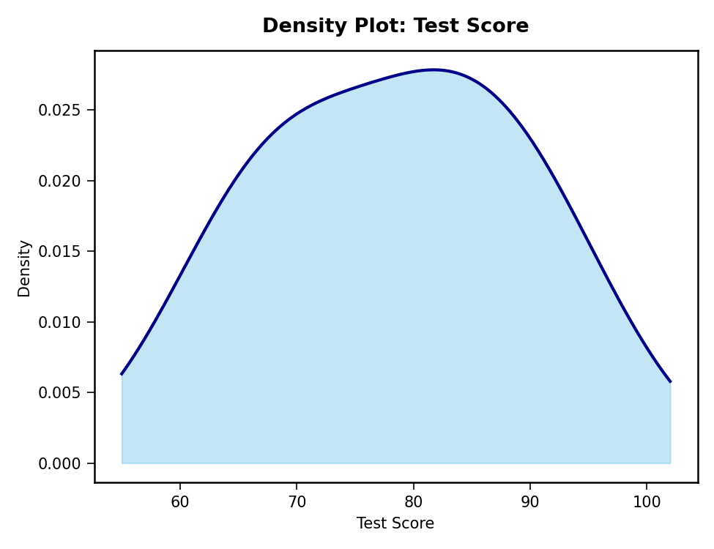
4) In Tableau, design an interactive scatterplot with Study_Hours on X-axis, Test_Score on Y-axis, colored by Participation_Score. Include filters for Age.
R code (interactive scatter simulation):
# Scatter Plot colored by Participation Score
library(ggplot2)
ggplot(student, aes(x = Study_Hours, y = Test_Score, color = Participation_Score)) +
geom_point(size = 5) +
scale_color_viridis_c(option = "plasma") +
labs(title = "Study Hours vs Test Score",
x = "Study Hours", y = "Test Score", color = "Participation")
output:
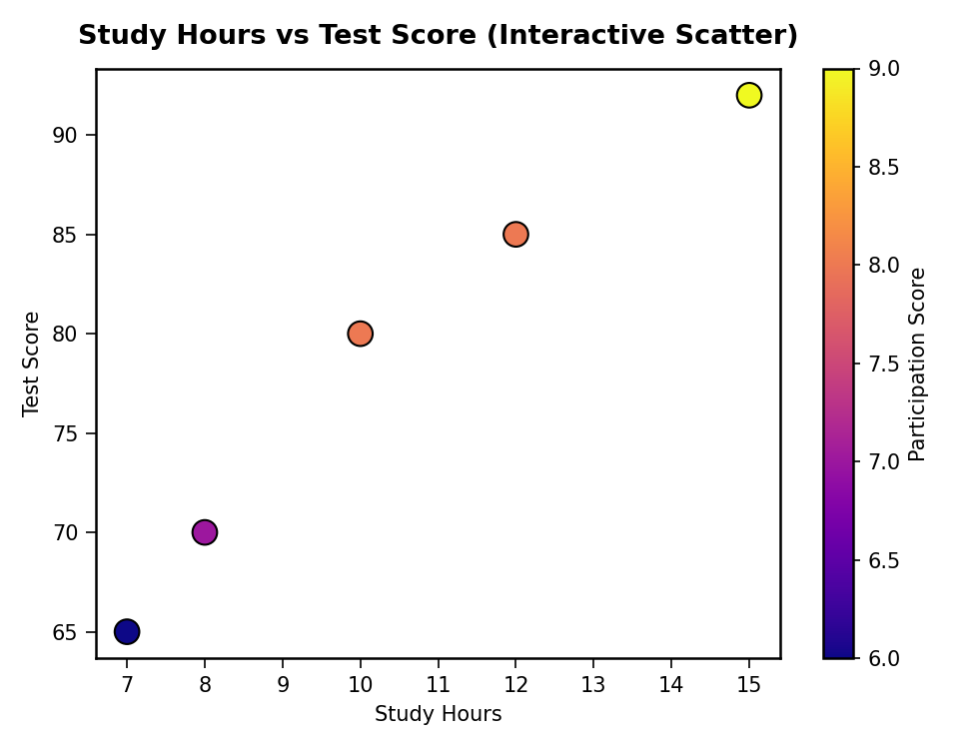
Dataset table used:
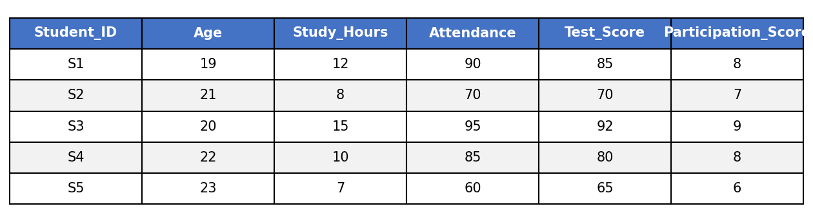

Set 30: Mobile App Usage Analysis
Dataset: Mobile_App_Usage.csv (User_ID, Gender, Age, Screen_Time, App_Usage_Count, Data_Used, Satisfaction, Usage_Date)
1) Import the dataset in R. Plot a histogram and density plot for Screen_Time. Add suitable colors and labels. Interpret the screen-time distribution.
R code:
# Import dataset
app <- read.csv("Mobile_App_Usage.csv")

# Histogram
hist(app$Screen_Time,
main = "Histogram: Screen Time", xlab = "Screen Time (hrs)",
col = "lightgreen", border = "black", breaks = 5)

# Density Plot
d <- density(app$Screen_Time)
plot(d, main = "Density: Screen Time",
xlab = "Screen Time (hrs)", col = "darkgreen", lwd = 2)
polygon(d, col = rgb(0.56, 0.93, 0.56, 0.5), border = "darkgreen")
output:
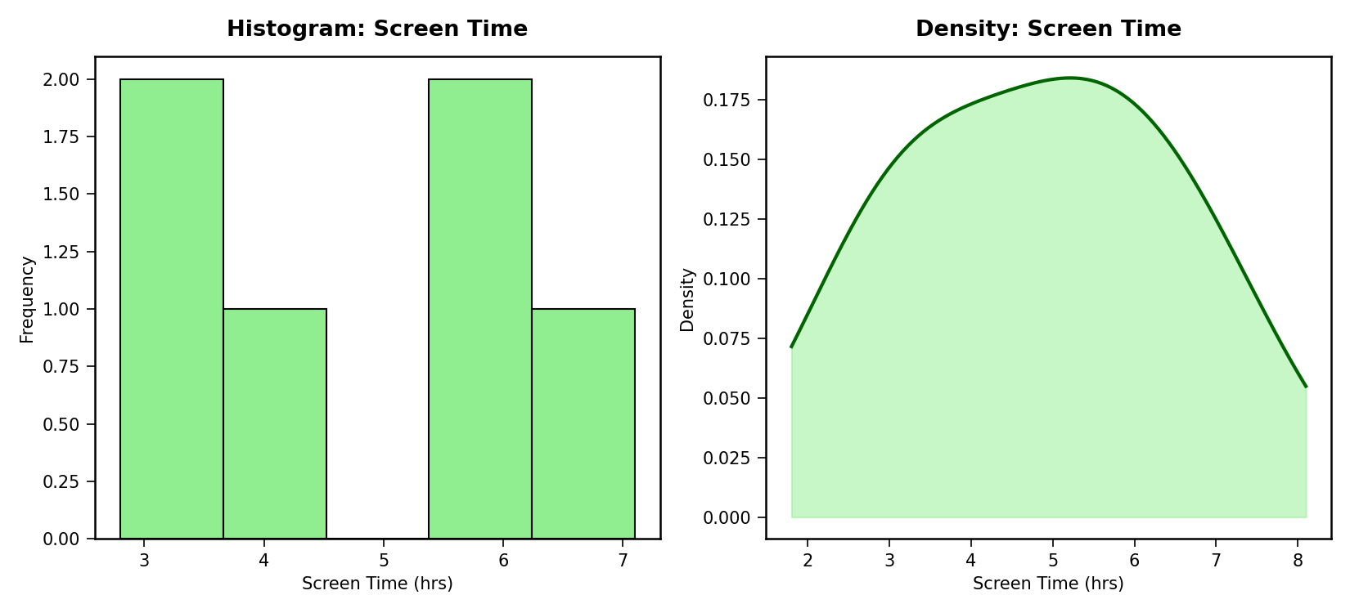
2) Create a scatter plot using R programming between Data_Used and Screen_Time. Calculate the correlation between them. Add a trend line. Explain the relationship.
R code:
# Scatter Plot with trend line
plot(app$Screen_Time, app$Data_Used,
col = "teal", pch = 16, cex = 1.5,
xlab = "Screen Time (hrs)", ylab = "Data Used (GB)",
main = "Screen Time vs Data Used")
abline(lm(Data_Used ~ Screen_Time, data = app), col = "red", lwd = 2)

# Correlation
cor(app$Screen_Time, app$Data_Used)
output:
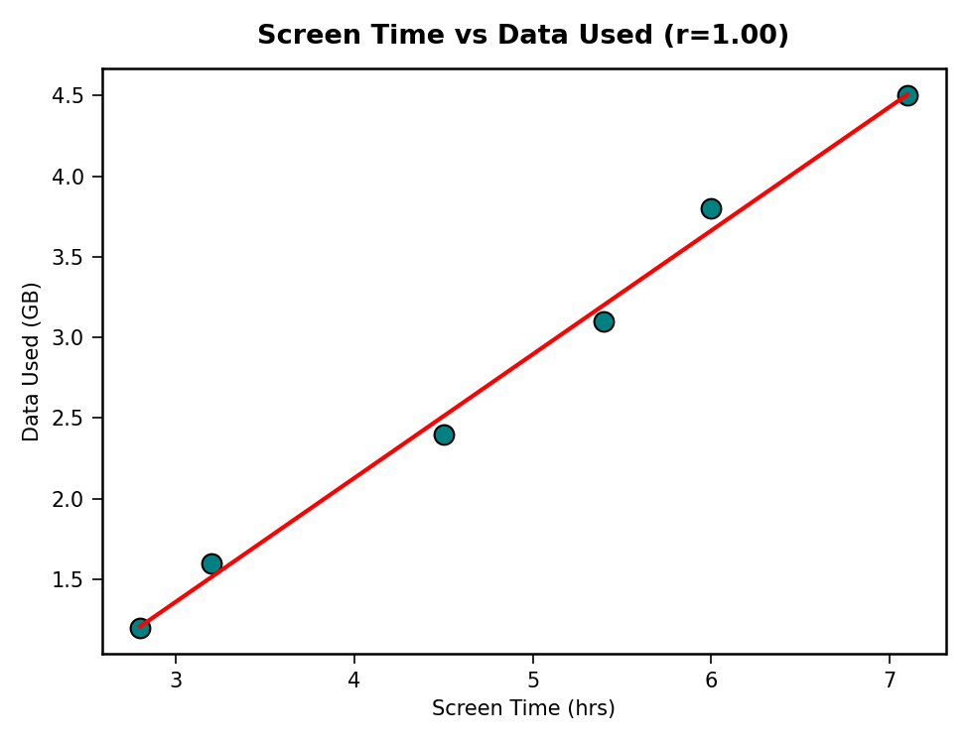
3) Using R, find the average Satisfaction score for each Gender. Create a bar chart for the averages. Add value labels. Interpret user satisfaction patterns.
R code:
# Average Satisfaction by Gender
avg_sat <- aggregate(Satisfaction ~ Gender, data = app, FUN = mean)

# Bar Chart with value labels
bp <- barplot(avg_sat$Satisfaction, names.arg = avg_sat$Gender,
col = c("#66B2FF","#FF99CC"),
xlab = "Gender", ylab = "Average Satisfaction",
main = "Average Satisfaction by Gender", ylim = c(0, 5))
text(bp, avg_sat$Satisfaction + 0.1, round(avg_sat$Satisfaction, 2))
output:
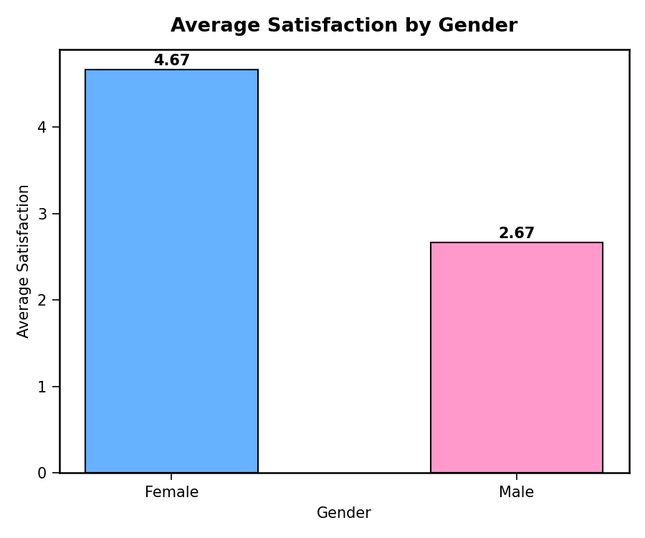
4) Import Mobile_App_Usage.csv into Tableau. Create a bubble chart (Screen Time vs Data Used). Use color for Gender and size for App Usage Count. Create a line chart for usage trends. Add filters for Gender and Usage_Date. Design a mini dashboard.
R code (dashboard simulation):
par(mfrow = c(1, 2))
symbols(app$Screen_Time, app$Data_Used,
circles = sqrt(app$App_Usage_Count),
inches = 0.25,
fg = "black",
bg = ifelse(app$Gender == "Male", "blue", "deeppink"),
xlab = "Screen Time (hrs)", ylab = "Data Used (GB)",
main = "Bubble Chart: Screen Time vs Data Used")

app$Usage_Date <- as.Date(app$Usage_Date)
app$Month <- format(app$Usage_Date, "%Y-%m")
monthly_screen <- aggregate(Screen_Time ~ Month, data = app, FUN = mean)
plot(monthly_screen$Screen_Time, type = "o", col = "purple", lwd = 2,
xaxt = "n", xlab = "Month", ylab = "Avg Screen Time (hrs)",
main = "Usage Trend Over Time")
axis(1, at = 1:nrow(monthly_screen), labels = monthly_screen$Month)
output:
